**Nordea**

**QA Engineer**

Vadim Kööp

Tallinn 2023

**Table of Contents**

1. QUESTION: 3

2. QUESTION: 4

3. QUESTION: 5

4. QUESTION: 6

5. QUESTION: 7

6. QUESTION: 8

7. QUESTION: 9

8. QUESTION: 10

9. QUESTION: 11

10. QUESTION: 12

11. QUESTION: 13

12. QUESTION: 14

13. QUESTION: 15

14. QUESTION: 16

15. QUESTION: 17

16. QUESTION: 18

18. QUESTION: 20

19. QUESTION: 21

# 1. QUESTION:

● (1 min) Prepare sql query that will select name, age and salary for everyone earning more

than 4000

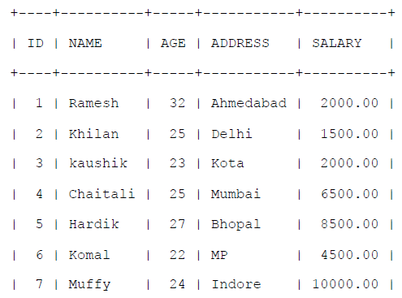

**Answer:**

SELECT NAME, AGE, SALARY FROM “Table Name” WHERE SALARY > 4000;

# 2. QUESTION:

**●** (1 min) What’s wrong in the following query?

SELECT subject_code, count(name)

FROM students;

**Answer:**

SELECT subject_code, count(name)

FROM students

GROUP BY subject_code;

# 3. QUESTION:

**●** (3 min) What’s wrong in the following query?

SELECT subject_code, AVG (marks)

FROM students

WHERE AVG(marks) > 75

GROUP BY subject_code;

**Answer:**

SELECT subject_code, AVG (marks)

FROM students

GROUP BY subject_code

HAVING AVG(marks) > 75;

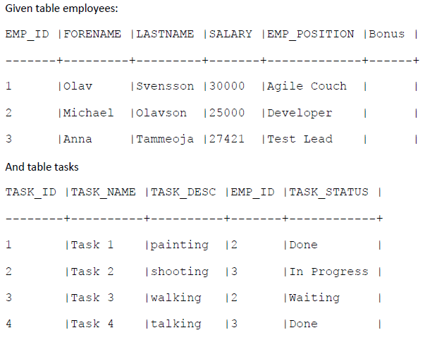

# 4. QUESTION:

● (2 min) You want to display name of employees, their tasks description and status, what is

wrong in such statement:

Select e.FORENAME, e.LASTNAME from e employees ,

t.TASK_DESC, t.TASK_STATUS from t tasks

join on e.EMP_ID = ’Done’

**Answer:**

SELECT e.FORENAME, t.TASK_DESC, t.TASK_STATUS

FROM employees as e

LEFT JOIN tasks as t

ON t.EMP_ID = e.EMP_ID;

# 5. QUESTION:

● (1 min) Insert to table employees new record for:

Mary Blumkvist with salary=39000 SEK on Business Analyst position.

**Answer:**

INSERT INTO employees (FORENAME, LASTNAME, SALARY, EMP_POSITION)

VALUES('Mary', 'Blumkvist', ‘39000’, 'Business Analyst position');

**OR**

INSERT INTO employees SET FORENAME = ‘Mary’, LASTNAME = 'Blumkvist', SALARY = ‘39000’,

EMP_POSITION = ‘Business Analyst position’;

# 6. QUESTION:

● (1 min) What is wrong in following statement:

insert into employees (forename=’Nanda’,lastname=’Kumar’, salary=’1700’,position=’Exploratory

tester’)

**Answer:**

INSERT INTO employees SET forename = ‘Nanda’, lastname = ‘’Kumar’’, salary = ’1700’, position =

’Exploratory tester’;

# 7. QUESTION:

● (1 min) Increase salary for all of them who have salary lower, then average salary. Raise

should be 10%.

**Answer:**

UPDATE employees SET salary = (salary + salary * 0.1) WHERE salary < (SELECT avg(salary) FROM

employees;

# 8. QUESTION:

● (2-4 min) Give employees bonus 1000DKK for each completed task in tasks table

**Answer:**

UPDATE employees AS e

JOIN (SELECT COUNT( tasks . TASK_ID) as done_tasks,

tasks.EMP_ID as emp_id

FROM tasks as tasks

WHERE TASK_STATUS = ‘Done’) AS table2

ON table2.emp_id = e.EMP_ID

SET e.BONUS = table2.done_tasks * 1000;

# 9. QUESTION:

● (4-6 min) Give bonus 5000 to everybody who has all tasks completed

**Answer:**

UPDATE employees AS e

JOIN (SELECT COUNT( tasks . TASK_ID) as done_tasks,

tasks.EMP_ID as emp_id

FROM tasks as tasks

WHERE TASK_STATUS != ‘Done’

HAVING done_tasks = 0) AS table2

ON table2.emp_id = e.EMP_ID

SET e.BONUS = 5000;

# 10. QUESTION:

● (1 min) Remove record of Olav Svensson

**Answer:**

DELETE FROM employees WHERE forename = ‘Olav’ AND lastname = ‘Svensson’;

# 11. QUESTION:

● (2 min) Display forename, last name how many task every employee finished – not including

those who has not finished any task an sort result ascending.

**Answer:**

SELECT e.FORENAME, e.LASTNAME, COUNT(t.TASKS_ID) as finished_tasks

FROM employees e

LEFT JOIN tasks t

ON t.EMP_ID = e. EMP_ID

WHERE t.STATUS = ‘Done’

GROUP BY t.EMP_ID

HAVING finished_tasks > 0

ORDER BY finished_tasks ASC;

# 12. QUESTION:

● (2 min) Display forename, last name how many task every employee finished – including

those who has not finished any task an sort result ascending.

**Answer:**

SELECT e.FORENAME, e.LASTNAME, COUNT(t.TASKS_ID) as finished_tasks

FROM employees e

LEFT JOIN tasks t

ON t.EMP_ID = e. EMP_ID

WHERE t.STATUS = ‘Done’

GROUP BY t.EMP_ID

ORDER BY finished_tasks ASC;

# 13. QUESTION:

● (1 min) How would you describe these words:

FIRST_VALUE, LAST_VALUE, LEAD, LAG, PERCENT_RANK, CUME_DIST, PERCENTILE_CONT,

and PERCENTILE_DISC

**Answer:**

Analytic functions

# 14. QUESTION:

● (2 min) How would you describe the “OVER Clause” as in this sample:

AVG(OrderQty) OVER(PARTITION BY SalesOrderID) AS "Avg"

**Answer:**

OVER clause defines a window or user-specified set of rows within a query result set. A window

function then computes a value for each row in the window.

The OVER clause is used to determine which rows from the query are applied to the function, what

order they are evaluated in by that function and when the function's calculations should restart.

# 15. QUESTION:

● (2 min) What does this show

SELECT STDEV(Bonus)

FROM SalesPerson;

**Answer:**

STDEV - standard deviation, statistics, standard deviation.

The SQL STDEV function is an aggregate function, which is used to calculate the standard deviation of

total records in row (Bonus) selected by the SELECT Statement From SalesPerson.

# 16. QUESTION:

● (1 min) What is illustrated here:

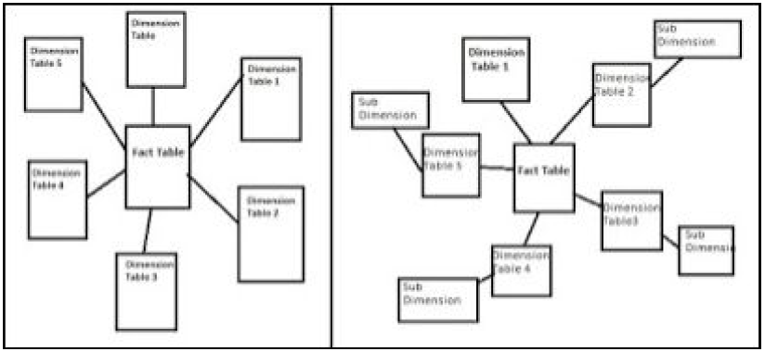

**Answer:**

Table tree with star schema or snowflake schema.

Star scheme when a simple structure 1 to 1 or 1 to * association between central and the rest tables.

Schema snowflake when associations * to *.

**17. QUESTION:**

● (1 min) What is this ?

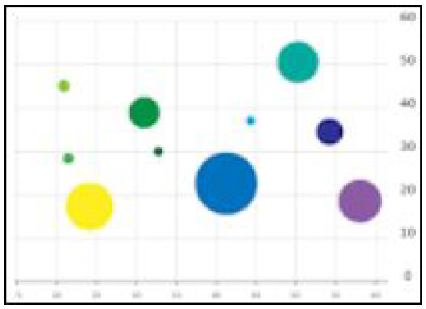

**Answer:**

Bubble chart

# 18. QUESTION:

● (2 min) What is a “Data steward” ?

**Answer:**

Data stewards bridge the communications gap between business and IT stakeholders about how data

is used and they care for data assets on behalf of the enterprise through governance and by assessing

and correcting data quality issues.

**Responsibilities:**

A data steward ensures that each assigned data element:

- Has clear and unambiguous data element definition

- Does not conflict with other data elements in the metadata registry, removes duplicates,

overlap etc

- Has clear enumerated value definitions if it is of type Code

- Remove unused data elements

- Use consistently in various computer systems

- Fit for purpose

- Has adequate documentation on appropriate usage and notes

- Documents the origin and sources of authority on each metadata element

- Is protected against unauthorised access or change

**Types of data stewards:**

- Data object data steward

- Business data steward

- Process data steward

- System data steward

**Benefits:**

- Faster analysis

- Consistent use of data management resources

- Easy mapping of data between computer systems and exchange documents

- Lower costs

- Better control of dangers associated with privacy, legal, errors, etc

# 19. QUESTION:

● (2 min) What is illustrated here in these two separate tables ?

**Answer:**

Results of dense_rank (left) and row_number (right) functions